附录A 1/f频谱图

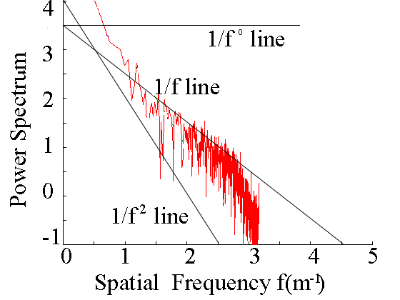
图A1 频谱图

附录B C的取值表

表B1 C的取值
C值 | 液体/蒸汽
20 | 紊流/紊流
12 | 层流/紊流
10 | 紊流/层流
5 | 层流/层流

附录C 一维1/f波动数据的生成

clear all
close all

M = 2*256;
K = 1;
f = 1:M;
s = K*1./f ;

figure(1); plot(s); grid;

LOGs = log10( s );
LOGf = log10( f );

figure(4); plot( LOGf,LOGs ); grid;

hh = sqrt( m*s );

m = 2*M-1;
h2( 1:M ) = hh( 1:M );
h2( M:m ) = hh( M:-1:1 );
figure(2); plot(h); grid;

pp = rand( 1,m );
re = h2 .* cos( pp ) ;
im = h2 .* sin( pp ) ;
hh = re + i*im ;

……

